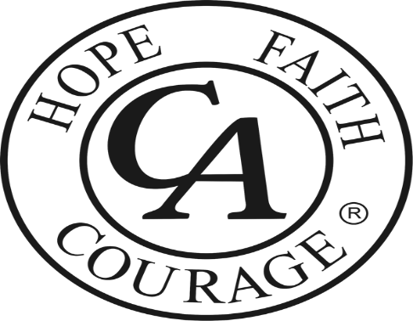

The Columbus District of Cocaine Anonymous Presents:

2024 “Celebrate Around-the-World” Speaker jam
Date: 3/30/2024 Time: 12-4 pm
Location: 1045 Ross Road, Columbus, Ohio 43227

3 great speakers
50/50 raffle
For more information please call: 614 251-1122
or email your questions to: columbusdca@gmail.com

Tradition 6. “A C.A. group ought never endorse, finance, or lend the C.A. name to any related facility or outside enterprise, lest problems of money, property and prestige divert us from our primary purpose.”

