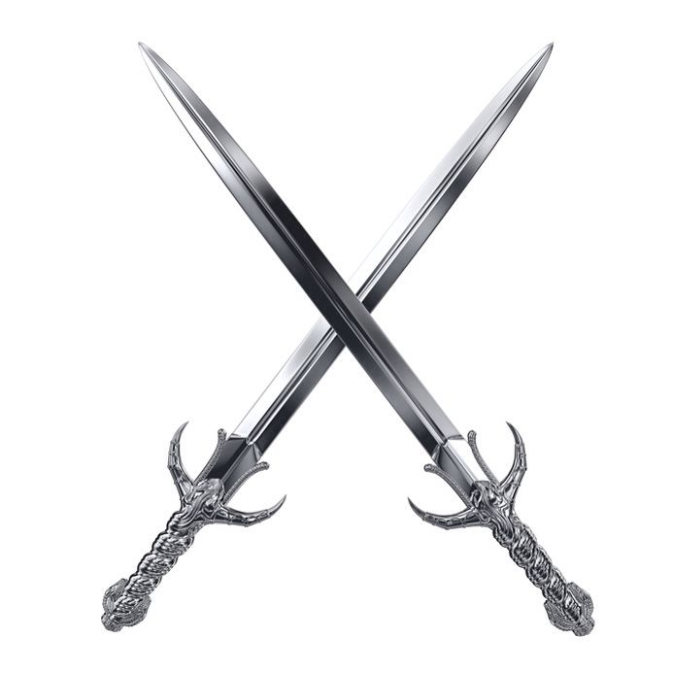
Iron Sharpens Iron
2nd Annual Men’s Conference

Iron
2nd Annual Anniversary Men’s Conference
Saturday May 4th, 2024
10a – 6p
St. Philip Lutheran Church
1506 E Long St
Columbus, Ohio 43203
$20 early registration thru Apr. 4th $25 day of event

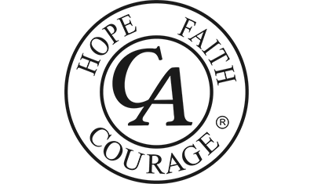
A C.A group ought never endorse, finance, or lend the C.A name to any related facility or outside enterprise, lest problems of money, property and prestige divert us from our primary purpose.

