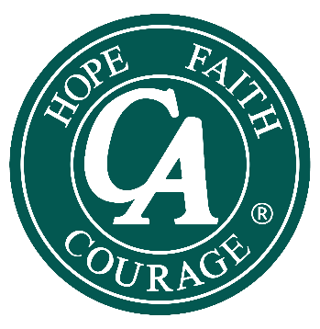

**Columbus District of C.A. Presents:**

**A UNITY SPEAKER JAM**

**Saturday, August 16, 2025**

**12-4:30 pm**

**ENJOY 3 FANTASTIC SPEAKERS**

**LIGHT REFRESHMENTS WILL BE SERVED**

**All are welcome at no charge!**

**Eastview United Methodist Church\***

**1045 Ross RD, Columbus, Ohio**

**FOR MORE INFORMATION CALL US AT 614 251-1122 OR EMAIL US AT** [**WWW.CACOLUMBUSOH.ORG**](http://WWW.CACOLUMBUSOH.ORG)

* In the spirit of Tradition Six, C.A. is not allied with any sect, denomination, politics, organization, or institution.