24th ANNUAL OHIO AREA
CA FUNDAY
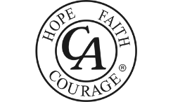

MOHICAN CANOE LIVERY
RT. 3 IN LOUDONVILLE, OHIO
AUGUST 1, 2026

Akron: Take 76 W. to St. Rt. 3 S. (last exit before 71) and follow all signs for St. Rt. 3 going to Loudonville. When you get into Loudonville, continue on Rt. 3 and Mohican Fun Center/Canoe Livery will be past McDonald’s on the left.

Bring chairs & blankets. Optional fun packets can be purchased for $52.00 each. This includes 1 canoe ride down Mohican River, 1 round of put-put golf and 2 go cart rides. These can be purchased individually if desired. Canoe ride only is $42.00. New Aerial Adventure Park added that can be used in place of canoe ride. Purchase of items done on individual basis…no group packages. Lots of fun, food, and fellowship. For more info contact Terry D. at 330-283-4105.

In the spirit of Tradition 6 CA is not allied with any sect, denomination, politics, organization, or institution.

